HILLY FIELDS FOOTBALL CLUB
SEASON 11: 1977-78
FIRST TEAM:
BECKENHAM LEAGUE:
P W D L F A Pts Pos
Division 3 16 11 3 2 60 18 25 3rd
Beckenham Hospital Cup 1 0 0 1 0 3
Beckenham League Cup 1 0 0 1 0 1
Burwood Cup 2 1 0 1 5 7
Cup 1 0 0 1 0 7
Friendly 5 2 0 3 8 10
TOTAL 26 14 3 9 73 46

Apps Gls Apps Gls
Les Bedden 15 3 Macolm Hill 23 17
Tony Byford 5 0 Phil Jesson 24 0
Colin Chandler 21 7 Terry Mills 25 3
Mark Cooper 24 5 Dennis Pankhurst 22 5
Paul Cowdrey 17 6 Derrick Pankhurst 24 10
Alan Folkard 22 2 Martin Parkes 1 0
Keith Foster 2 0 Bob Whybrow 18 7
Len Franklin 22 7 Ivor Yexley 1 0
Larry Garnham 1 0 Gary Young 1 0
Dave Green 22 0 OG 1
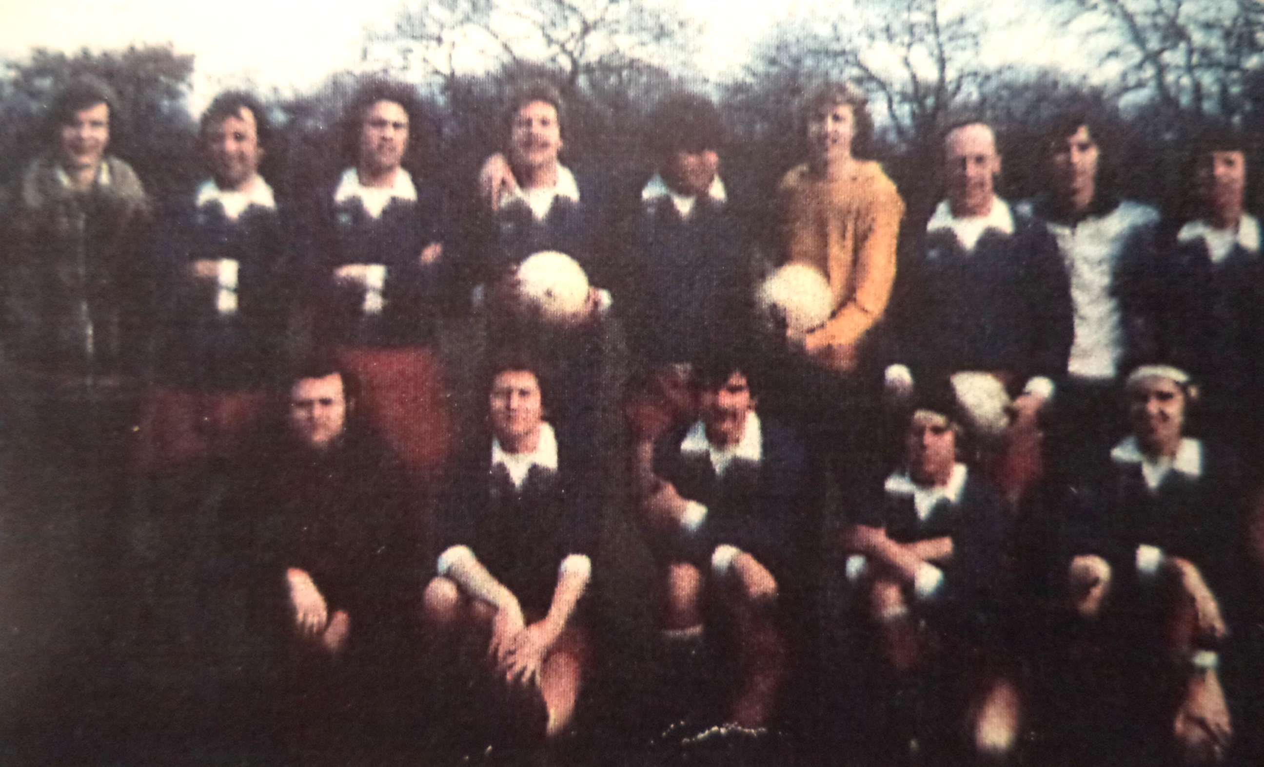
L-R Back: Keith Foster,Dave Green,Terry Mills,Mark Cooper,Colin Chandler, Phil Jesson,Les Bedden,Bob Whybrow,Malcolm Hill,Len Franklin,
L-R Front: Tony Byford,Paul Cowdrey,Gary Young,Derrick Pankhurst,Alan Folkard

